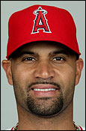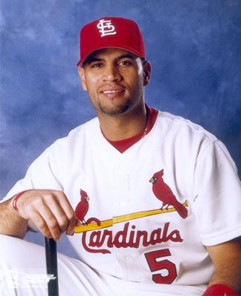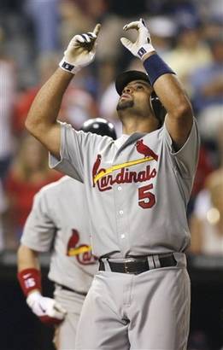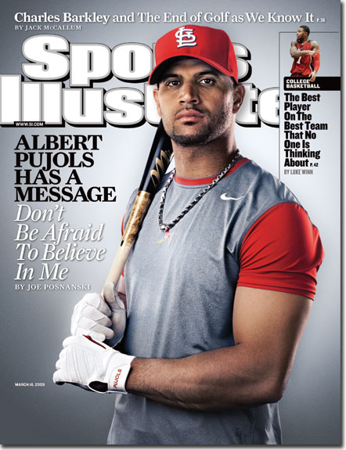

Los Angeles Angles Now St Louis Cardinals Giving God Credit for Win Cover SI Wife Deidre Pujols

Who is Albert Pujols?
Albert Pujols is the slugging superstar first baseman for the Los Angeles Angels and did play for St. Louis Cardinals. He is playing his fifth season in the Major Leagues. In Albert's first season with the Cardinals, he won the 2001 National League Rookie of the Year award. There was no "sophomore jinx" for Pujols. He came in second to Barry Bonds in NL MVP voting in both 2002 and 2003. Albert Pujols was the NL's leading vote getter for the 2003 All-Star Game. Pujols also won his first batting title in 2003 with a .359 batting average. The St. Louis Cardinals rewarded Pujols with a 7 year, $100,000,000 contract, the largest deal in franchise history.
Albert Pujols was born Jose Alberto Pujols on January 16, 1980 in Santo Domingo in the Dominican Republic. In 1996, at the age of 16, Albert Pujols moved to the United States, settling in the Kansas City area. He graduated from Fort Osage High School in Independence, Missouri, after twice earning all-state honors in baseball. He made a name for himself at Maple Woods Community College where he earned a baseball scholarship, and was drafted by the St. Louis Cardinals in the 13th round of the 1999 free agent draft. After only one year in the minors, Pujols was invited to spring training with the Cards. His performance was so good that he never got sent back down to the farm team.
Albert's wife Deidre has a daughter with Down Syndrome, whom Pujols has adopted. Albert Pujols does a lot of charity work with the Down Syndrome Association Of Greater St. Louis. He has also recently set up the Pujols Family Foundation.
